Describe how to tell if something is a…
Translation _________________________________________________________________
Reflection__________________________________________________________________
Rotation____________________________________________________________________
Make your parallelogram family tree, write down the properties.

Translate the following shape
(x,y) -> (x-5,y+1)
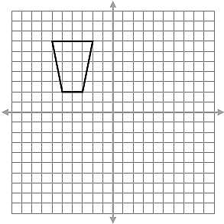

Rotate shape 90 degrees, counter clockwise around the origin.

Reflect the trapezoid over the line drawn.
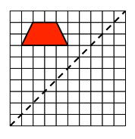
Triangle Congruency – write yes or no and why.
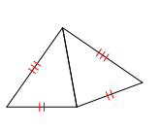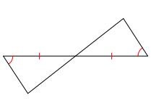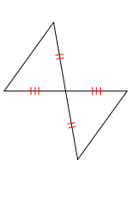
What additional information would be needed to prove congruency using ASA?
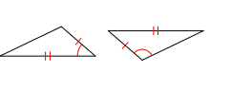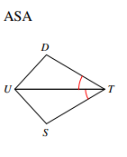
Find all the diagonals of a regular hexagon.
Find all the lines of symmetry.
Find all the degrees of rotational symmetry.

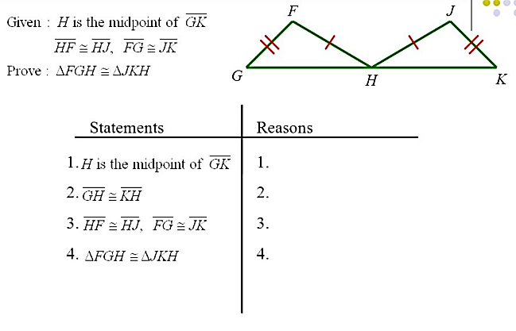
Write a rule for each transformation.
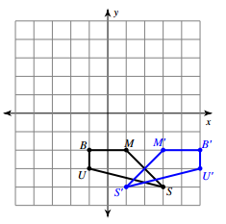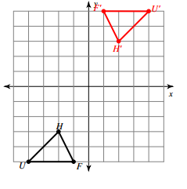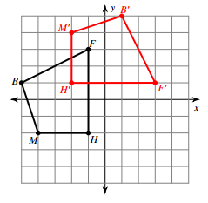
- Find and draw the line of reflection, that reflects A to B
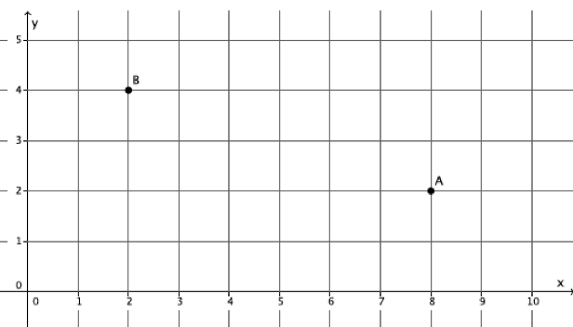
b. Find the slope of line AB

c. Find the perpendicular slope of AB.

d. Find the midpoint of line AB.

