Steps:
Adding/Subtracting
- Find the non trig function – look for the function that the trig function is going around and sketch it through the middle of the trig graph – this is the midline
- Find the trig function – if trig function starts on the midline it is sin, if not cos
- Find the period – take that number and set it equal to $\frac{2π}{x}$
- Find the amplitude – how far it goes up or down from the start
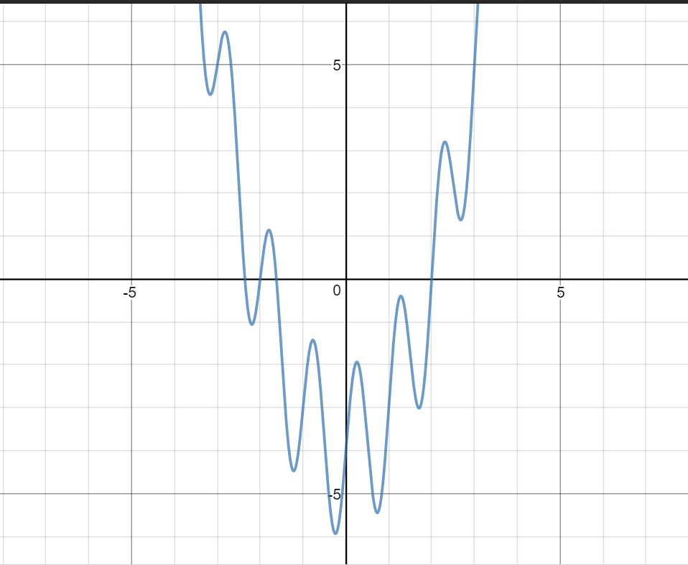
Multiplying
- Find function that creates the boundaries
- Find trig function – look at whether the graph is odd or even if linear boundaries, or look at intercepts and important points
- Find period

