**Module 6 Practice Worksheet Name: _______________________________**



1. Which of the following triangles might *not* be   
   congruent to the triangle to the right?

|  |  |  |
| --- | --- | --- |
| a. | b. |  |
| c. | d. | g. |
| e. | f. | h. |
|  |  |  |

2. Construct a perpendicular bisector of $\overline{AB}$ using only a compass and a straight edge. Write out a numbered list with each step.

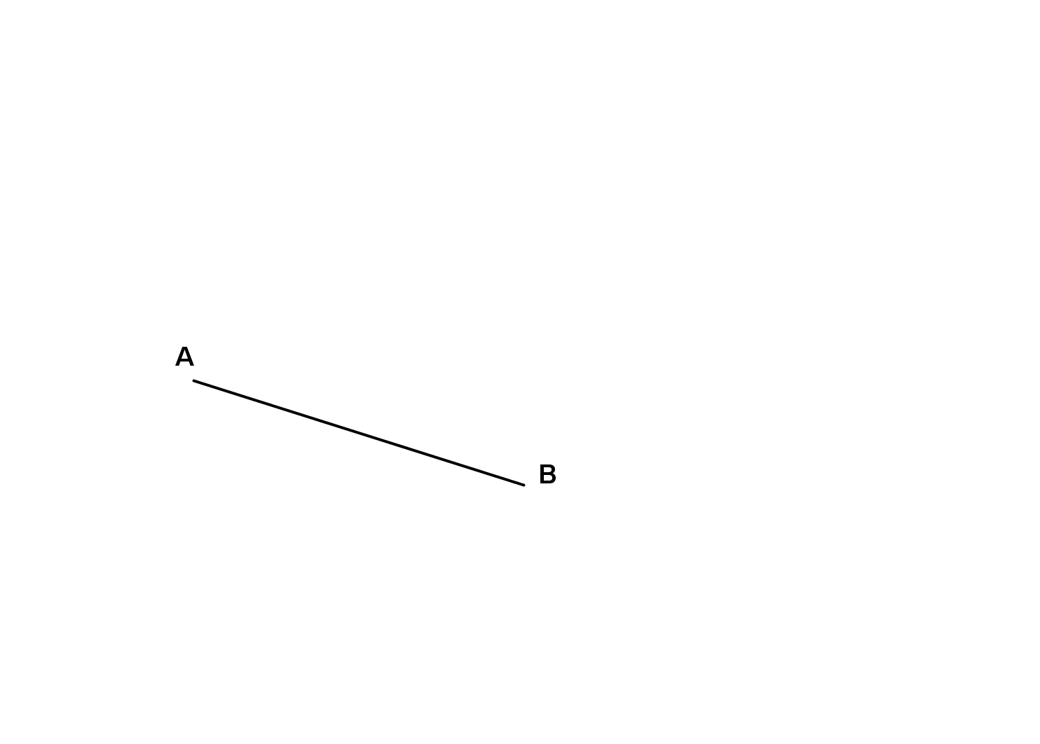

3. Construct a rhombus with the given angle and line segment using only compass and straight edge. Write out a numbered list with each step.

4. Construct an angle bisector for the given angle using only compass and straight edge. Write out a numbered list with each step.

5. Copy the angle below using only compass and straight edge. Write out a numbered list with each step.

*Using the diagram to match the Image/Pre-Image listed on the left with the transformation listed on the right.*

|  |  |
| --- | --- |
| __ ____6. Pre-image: Shape I  Image: Shape II  __ ____7. Pre-image: Shape II  Image: Shape III  __ ____8. Pre-image: Shape IV  Image: Shape II  __ ____9. Pre-image: Shape I  Image: Shape IV  __ ____10. Pre-image: Shape I  Image: Shape III | a. Rotated 180° around the point (0 , 0)  b. Reflected over the line $y=-x$ c. Rotated 270° counter-clockwise around (0 , 0)  d. Reflected over the line $y=0$ e. Rotated 90° counter-clockwise around (0 , 0) |

|  |  |
| --- | --- |
| 1. A(1,5) is reflected so that its image is at   A’(5,-1). Graph the line of reflection on the plane below, and find the equation in slope intercept form.  y = ____________________ | 1. Given triangle **XYZ** and its image **X’Y’Z’** draw the line of reflection that was used. 2. Write the equation of the line of reflection you drew. |
|  |  |

1. **Pre-image: $A(3, 1)$, $B(-2, 1)$, $C(-2,-2)$**

|  |  |
| --- | --- |
| **Perform the following sequence of transformations:**  Reflect the image over the given line (line *L*), then rotate $180°$ around the origin, then translate up 5 units. |  |

|  |  |
| --- | --- |
| 1. Translate the figure according to the given translation rule.   (x, y) 🡪 (x + 5, y – 2)  [image] | 1. The bold figure is a translation of the non-bold figure. Write a rule to describe the translation.   [image] |

1. Consider $∆ABC$ and $∆DEF$. If  and , what additional information would you need to prove that the triangles are congruent by SAS?
2. Use the figure to the right to complete the proof.

𝑃rove Δ*ABE* http://00.edu-cdn.com/files/static/learningexpressllc/9781576857458/CONGRUENT_TRIANGLES_04.GIF ΔDCE

By: ____________________

* ______________ http://00.edu-cdn.com/files/static/learningexpressllc/9781576857458/CONGRUENT_TRIANGLES_04.GIF _______________
* ______________ http://00.edu-cdn.com/files/static/learningexpressllc/9781576857458/CONGRUENT_TRIANGLES_04.GIF _______________
* ______________ http://00.edu-cdn.com/files/static/learningexpressllc/9781576857458/CONGRUENT_TRIANGLES_04.GIF _______________

|  |  |
| --- | --- |
| 1. Write the equation of the line parallel to the line $y=3x-1,$ and that has a y-intercet of 5. | 1. Draw a line perpendicular to the line given. Write the equation of the new line below.   Image result for graphed line  Equation: __________________________ |
| 1. Find the slope between the pair of points. Then, using the Pythagorean Theorem, find the distance between each pair of points. You may use the graph to help you as needed. Leave all answers as reducded radicals if necessary. $$\left(-2,-4\right) \left(3, 6\right)$$ $a.$ Slope: $b.$ Distance: |  |
| 21. Reflect the triangle over the line y=x. | 22. Rotate the triangle $-90°$ clockwise, about the point . |

23. Find the angle(s) of rotation that will carry the 12 sided polygon below onto itself.

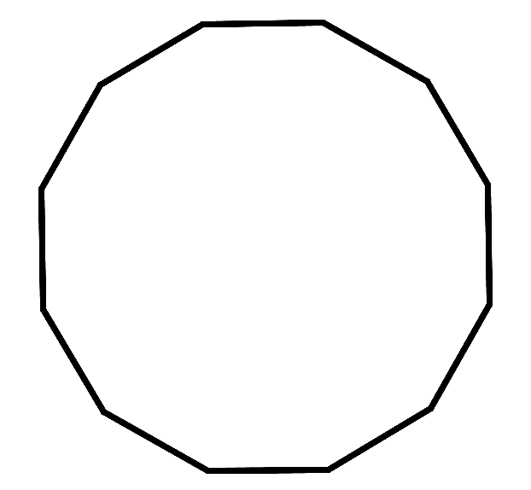

24. What are the angles of rotation (less than $360°)$ for a 20-gon? How many lines of symmetry (lines of reflection) will it have?

25. What are the angles of rotation (less than $360°)$ for a 15-gon? How many line of symmetry (lines of reflection) will it have?

26. How many sides does a regular polygon have that has an angle of rotation equal to 18 $°$? Explain.

27. How many sides does a regular polygon have that has an angle of rotation equal to 20 $°$? How many lines of symmetry will it have?

28. Find the sequence of transformations that will carry $∆RST$ onto $∆R’S’T’$. Clearly describe the sequence of transformations below each grid.

a. b.

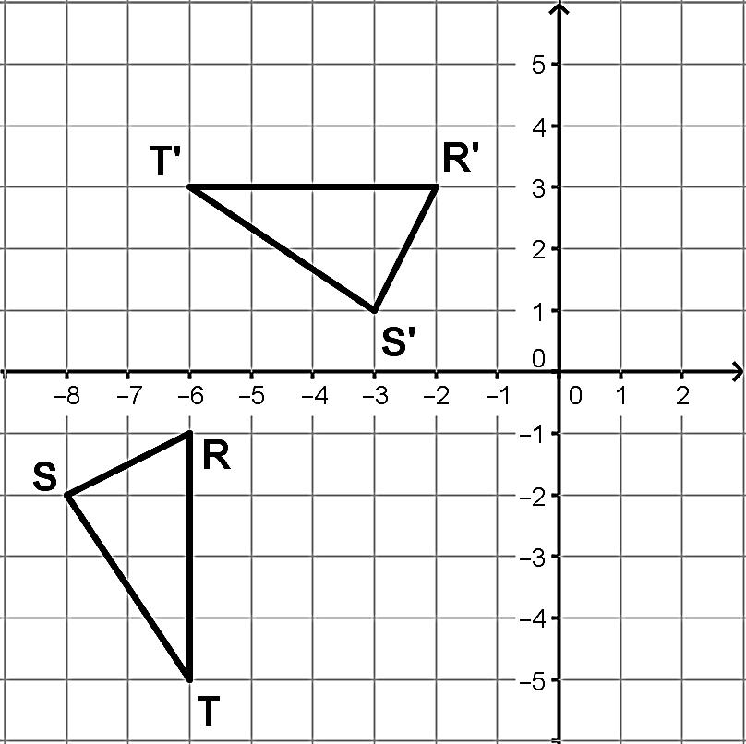 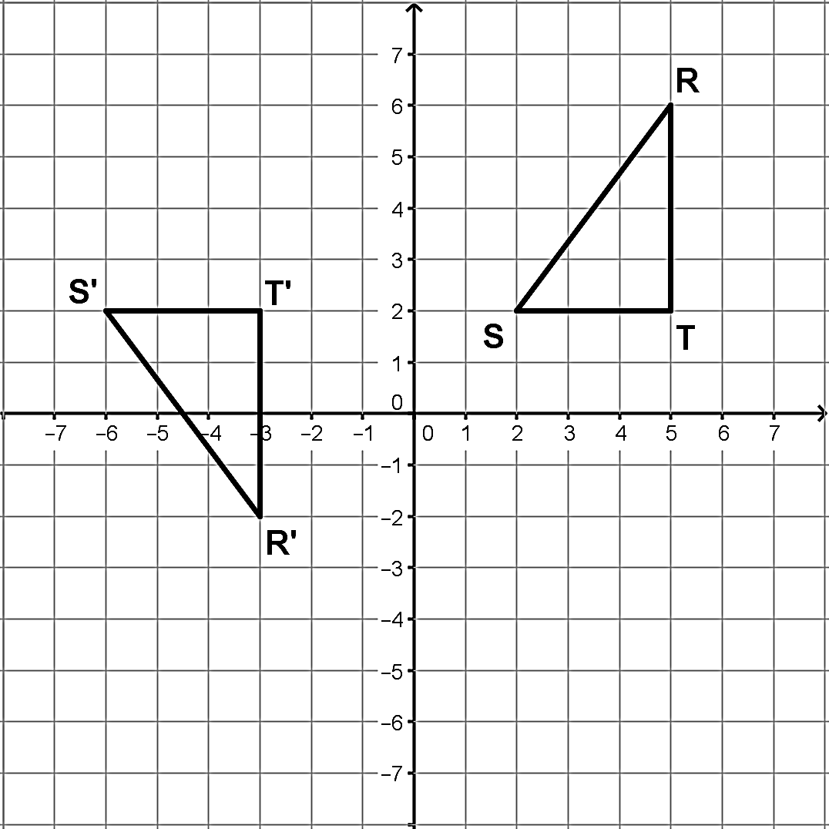

Determine whether or not the statement is true or false. If true, explain why. If false, explain why not or provide a counterexample.

29. If one triangle can be transformed so that one of its angles and one of its sides coincide with another triangle’s angle and side then the two triangles are congruent.

30. If one triangle can be transformed so that two of its sides and any one of its angles will coincide with two sides and an angle from another triangle then the two triangles will be congruent.

31. If three angles of one triangle are congruent to three angles of another triangle, then there is a sequence of transformations that will transform one triangle onto the other.

32. If three sides of one triangle are congruent to three sides of another triangle, then there is a sequence of transformations that will transform one triangle onto the other.

33. For any two congruent polygons there is a sequence of transformations that will transform one of the polygons onto the other.

34. State whether each pair of triangles is congruent. If they are congruent, state how you know.

|  |  |  |
| --- | --- | --- |
| a. | b. | c. |
| d. | e. | f. |

|  |  |
| --- | --- |
| **Classify each as true or false:**  35. Opposite sides of a rectangle must be parallel.  36. The sum of all interior angles of a quadrilateral add up to 330 $°$.  37. Opposite angles in a rhomus much be equal.  38. All diagonals are lines of symmetry. | |
| **For 39-44, write the letter of *every* special quadrilateral that has the given property.**  A Parallelogram B Rectangle C Rhombus  D Square E Trapezoid  39. All sides congruent. 40. All angles are congruent.  41. Opposite sides congruent. 42. Has 90 $°$ rotational symmetry.  43. Exactly one pair of parallel sides. 44. Has 4 lines of symmetry. |