Module 5 Practice Quiz
1. $y=-2x⋅(3cos{\frac{π}{2}x)}$  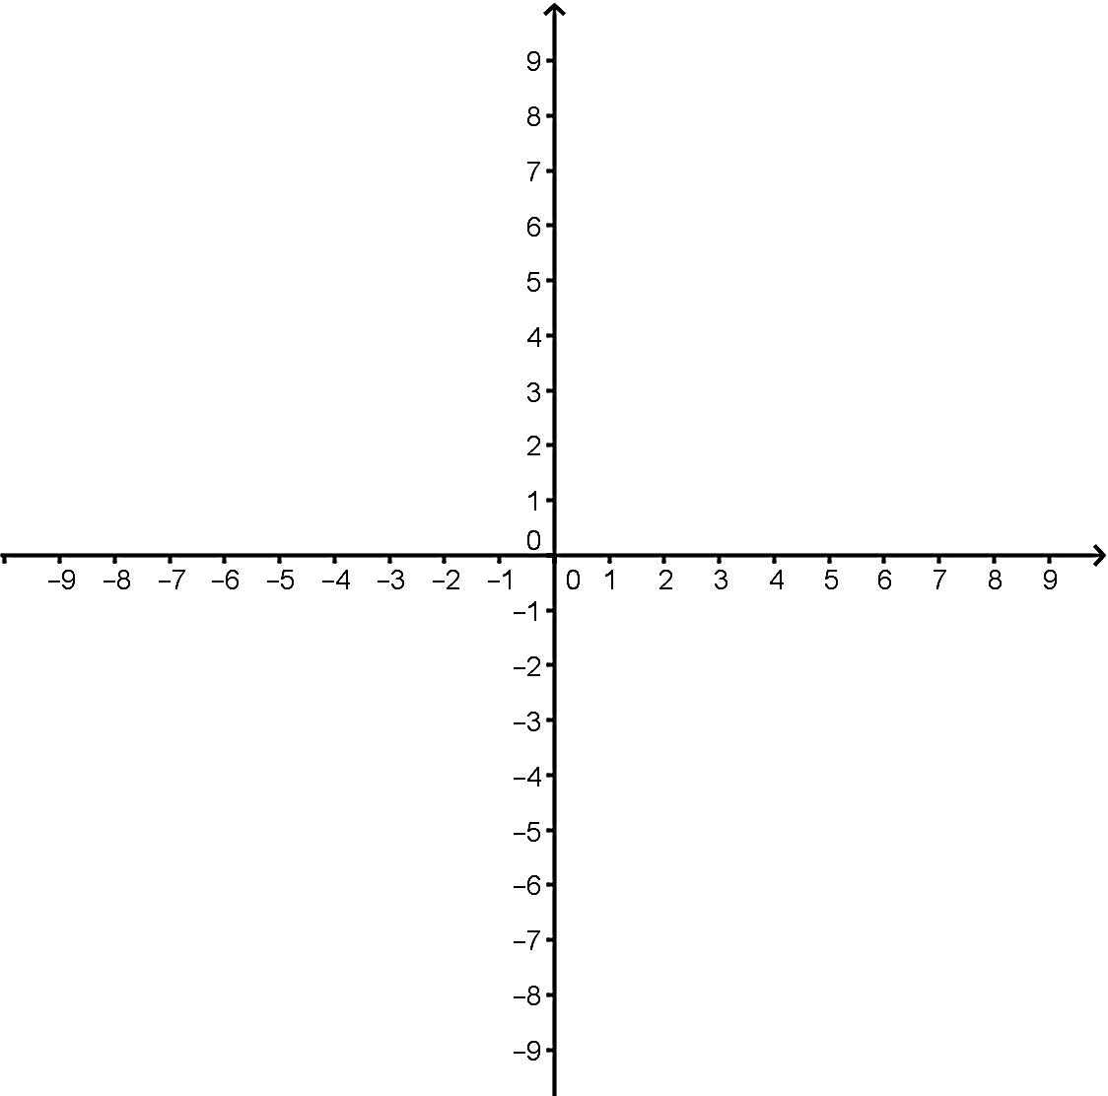 | 2. $y=\sin\left(\frac{3π}{2}x\right)+2x-1$
3. y=  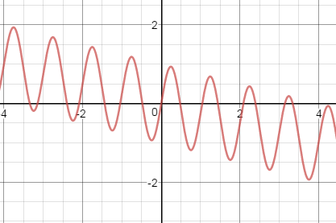 | 4. y=  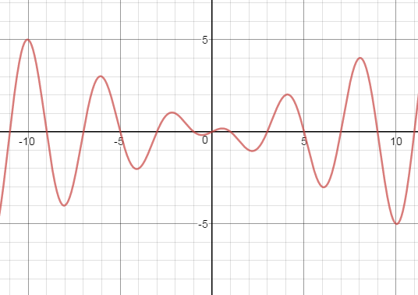
Complete the table
 | Pre-image  (parent graph) | Image 1 | Image 2 | Image 3
Geometric notation | $$(x,y)$$
Function notation | $$f\left(x\right)=\sqrt[3]{x}$$
Selected points that fit this image | $$\left(0, 0\right)$$ | $$\left(0, 0\right)$$ | $$\left(0, 1\right)$$ | $$\left(3, 0\right)$$
 | $$\left(1, 1\right)$$ | $\left(1,\frac{1}{2}\right)$ | $\left(\frac{1}{2},2\right)$ | $$(4, 2)$$
 | $$\left(8, 2\right)$$ | $$\left(8, 1\right)$$ | $$\left(4, 3\right)$$ | $$\left(11, 4\right)$$
 | $$\left(27, 3\right)$$ | $\left(27,\frac{3}{2}\right)$ | $\left(\frac{27}{2},4\right)$ | $$\left(30, 6\right)$$
 | $$\left(64, 4\right)$$ | $$\left(64, 2\right)$$ | $$\left(32, 5\right)$$ | $$\left(67, 8\right)$$

