Name: __________________
Module 7 Study Guide
For problems #1-2, find the slope and distance between the given points. Simplify all radicals if possible.
- (15, 9), (-7, -27) |  | - (-10, 2), (5, -7)
- Write the definition of the following quadrilaterals.
Parallelogram:

Rectangle:

Rhombus:

Square:

- Show that quadrilateral A(-5, -4), B(1, -2), C(2, 3) and D(-4, 1) is a parallelogram.  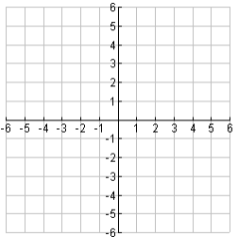 |  | - Show that quadrilateral A(-1, -3), B(4, 2), C(3, 9) and D(-2, 4) is a rhombus.  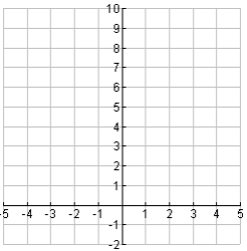
- Show that A(-4, -1), B(-2, 7), and C(1, 2) are the vertices of an isosceles right triangle. |  | - Find the perimeter of the following shape.  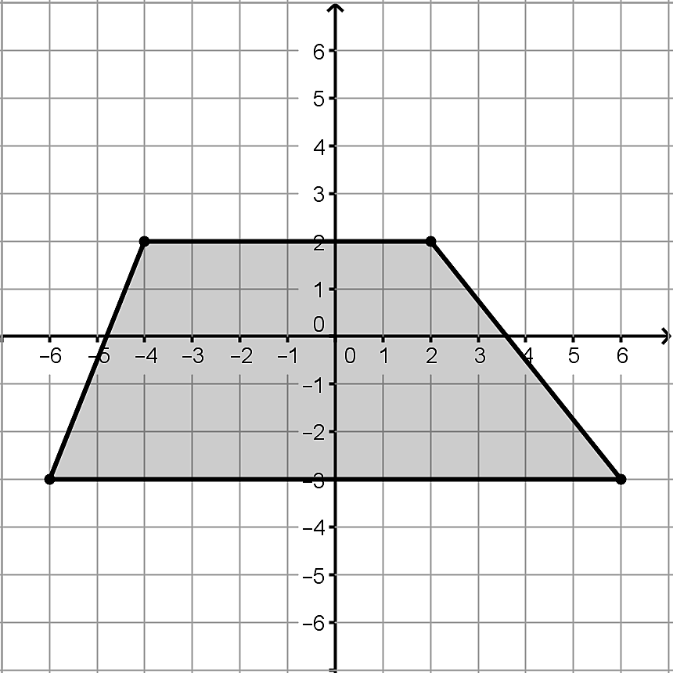
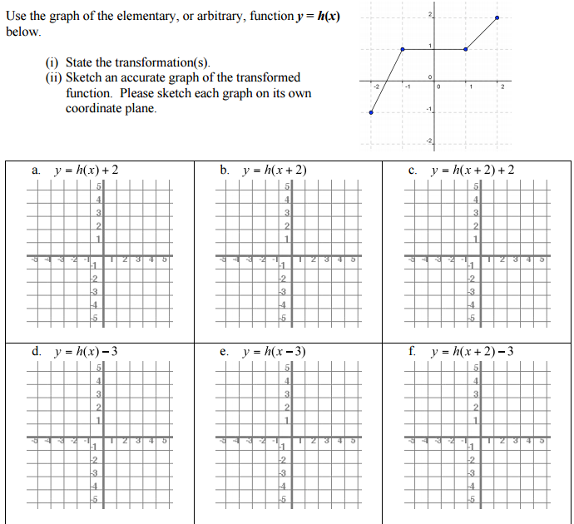

- The function to the left is $f\left(x\right)=x^{3}$. Write the equation for the following translations, and then graph the new function  - Shift up 3, $g\left(x\right)=$  - Shift to the left 5, $h\left(x\right)=$  - Shift down 2 and to the right 7,  $k\left(x\right)=$ |  | 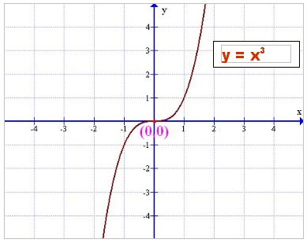
- The function to the right is g(x). Graph the following functions.  - h(x)=g(x+2)  - j(x)=g(x)-4  - k(x)=g(x-1)-3 |  | 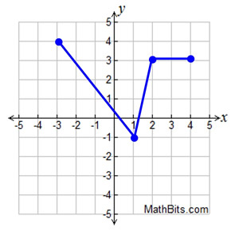
- The original function $f\left(x\right)=x^{2}$ has been shifted and reflected to create 3 new graphs. Label and write the equation of the each new graph. |  | 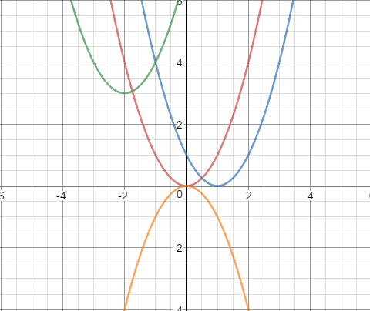
- Given the graph to the right:  Translation Form: $$g\left(x\right)=$$  Slope-Intercept: $$g\left(x\right)=$$ |  | 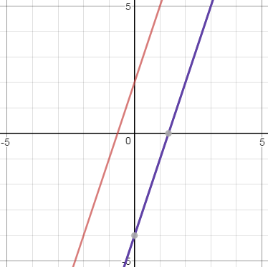  $$f(x)$$  $$g(x)$$
- Given the following functions:$k\left(x\right)=z\left(x\right)+ 52 and k(x)=-3x + 1$

Translation Form: | $$z\left(x\right)=$$ | Slope-Intercept: | $$z\left(x\right)=$$

- Angela and Kristen are comparing how much sleep they get each week. They realize they sleep the same amount each weekday, but sleep different amount over the weekend. Angela says I get 8 hours of sleep each weekday, and I sleep for 20 hours over the weekend. Kristen says she gets 24 hours over the weekend.

  - Write explicit functions in slope-intercept form to represent Angela’s $A(x)$ and Kristen’s $K(x)$hours of sleep.

$A\left(x\right)= __________________________$ $K\left(x\right)= ________________________$

  - Is there a vertical translation between the two explicit functions? If yes, write one explicit function as a translation of the other. If no, explain why not.

- On a sunny day in San Diego a tortious and a hare decide to race. The hare is so confident, that it allows the tortious to start 5 minutes before him. What the hare doesn’t know is that the tortious has been training, and now runs at the same pace. If both creatures run at a pace of 2 meters per second, graph their distance vs. time below.
a.  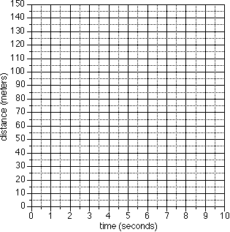 | b. Write explicit functions, in slope intercept or point slope form, to represent each animal.  $H\left(x\right)=$ $T\left(x\right)=$  c. Is there a vertical or horizontal translation between the two explicit functions? Write one explicit function as a translation of the other.

