Math 1 Module 1 Practice Problems Name: _________________________________ Per: ______

|  |  |
| --- | --- |
| 1. Graph | 1. Write the equation of the line graphed below. |

1. Use the pattern below to answer the following questions.

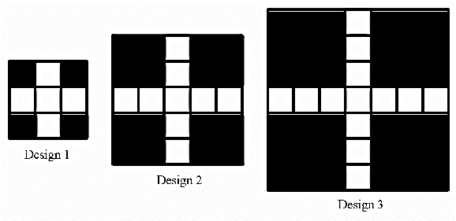

1. How many white tiles are in Design 50?

1. Write an expression that would help you calculate the number of tiles in Design *n*.

1. The white tiles represent a beautiful and expensive marble tile. You cannot afford to buy any more than 100 tiles. Which is the largest design you can afford?
2. Which graph matches the equation $2x+6y=24$?

|  |  |  |  |  |  |  |  |
| --- | --- | --- | --- | --- | --- | --- | --- |
| a. |  | b. |  | c. |  | d. |  |

1. Which inequality is best represented by the following number line?



|  |  |  |  |
| --- | --- | --- | --- |
| a. | $$10<22+3x$$ | b. | $$10≤22+3x$$ |
| c. | $$10>22+3x$$ | d. | $$10≥22+3x$$ |

1. Which number line best represents the inequality $-4\left(x-2\right)+5<9$?

|  |  |
| --- | --- |
| a. |  |
| b. |  |
| c. |  |
| d. |  |

1. If you solve the equation $3x+5y=20$ for *y*, what would you get?

**Use the following scenario for the two (2) questions below.**

*Willow is driving on the freeway. She just passed mile marker 325. The fastest she will drive is 75 miles per hour, though, there is a bit of traffic that might slow her down a bit, but she doesn’t know exactly how much. The mile markers are increasing on her route.*

1. If *y* is Willow’s speed, what is the inequality that a represents Willow’s speed?

|  |  |  |  |  |  |  |  |
| --- | --- | --- | --- | --- | --- | --- | --- |
| a. | *y* < 75 | b. | *y* > 75 | c. | *y* ≤ 75 | d. | *y* ≥ 75 |

1. The expression 325 + 2*y* represents what mile marker she’s at after 2 hours, depending on traffic. Which inequality describes the mile marker she would be at this point?

|  |  |  |  |  |  |  |  |
| --- | --- | --- | --- | --- | --- | --- | --- |
| a. | 325 + 2*y* < 475 | b. | 325 + 2*y* > 475 | c. | 325 + 2*y* ≤ 475 | d. | 325 + 2*y* ≥ 475 |

1. Find all of the values of x that make the following inequality true. Write your answer as an inequality. $2\left(x+5\right)≥4x+4$.
2. Graph your answer from the previous question on the number line below.



1. Write the inequality whose solution is represented by the number line. Define a variable which could be represented by the graph (include units) and write a sentence describing the inequality in context.



Inequality: ____________________________

Variable: ____________________________

Context:

1. Rewrite the following equation in slope-intercept form (*y* = *mx* + *b*), then graph it below.

$12y+2x=24$

Slope-Intercept form: ______________________________

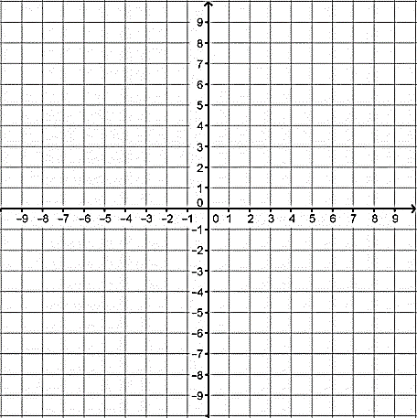

slope: ______________ *y*-intercept: _____________

1. **For the growing pattern below, each line segment is one unit in length.**

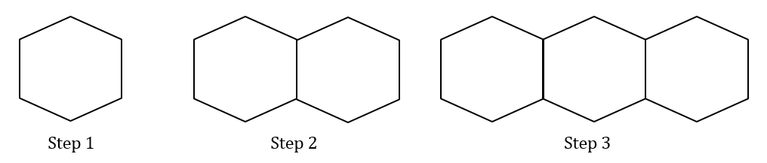

a. How much total ***perimeter*** in Step 5? (Remember to focus on the **perimeter**.)

b. How can you determine the amount of perimeter in Step 25?

c. Write a rule to predict the total amount of perimeter for any step. **Show how your rule relates to the pattern.**