**Name:_________________________**

**Math 1 Spring 2017**

**Final Review**

**All assignments are due the day after they are assigned**

|  |  |  |
| --- | --- | --- |
| **HW#** | **In Class** | **Assignment Details** |
| 42  4/3  M | Review Module 1-2 | Review Packet |
| 43  4/4  T | Review Module 3-4 | Review Packet |
| 44  4/5  W | **Final** | ☺ |
| 45  4/6  Th | Review Final | ☺ Happy Spring Break! ☺ |

**MODULE 1:**

**Solve the following equations for the unknown variable.**

1. 2.

1. Write an equation that represents the scenario below.

* Some students are sitting at the front table. (I got distracted by an incident in the back of the lunchroom, and forgot to record how many students.)
* Each of the students at the front table has been joined by a friend, doubling the number of students at the table.
* Four more students have just taken seats with the students at the front table.
* The students at the front table separated into three equal‐sized groups and then two groups left, leaving only one‐third of the students at the table.
* As the lunch period ends, there are still 12 students seated at the front table.

1. Write a scenario that matches the equation below.
$$\frac{2\left(x+4\right)}{3}=12$$

2. Solve the following equation for x.

$3x+5y=20$

$7x – 3y = 21$

**Graph each line.**

6. 7.

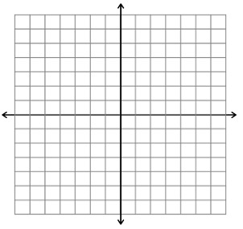

**#8-11. Solve each inequality. Graph the solutions on the number line AND state 3 numbers in the solution set. Show all your work!**

8. $2x+7>17$

-5

0

5

3 numbers in the solution set:

9. $20>6z+2$

-5

0

5

3 numbers in the solution set:

11. $7y-1≤29+2y$

-5

0

5

3 numbers in the solution set:

**Solve. Then graph the solution.**

|  |  |
| --- | --- |
| 12. | 13. |
| 14. | 15. |
| 16. | 17. |

**MODULE 2:**

**For #18 solve each system of equation by graphing:**

|  |  |
| --- | --- |
| 18. $y + x = 5$ $y = -2x + 8$ |  |

**For #13-14, solve each system of equations using the substitution or elimination:**

|  |  |
| --- | --- |
| 19. $y = -x + 15$ $4x + 3y = 38$ | 20. $2x – 3y = 4$ $x + 4y = -9$ |

**For #21-22, solve each system of inequalities.**

|  |  |
| --- | --- |
| 21. | 22. |

23. Jason is buying wings and hot dogs for a party. One package of wings costs $7. Hot dogs cost $4 per pound. He must spend less than $40.

a. Write an inequality to represent the cost of Jason’s food for the party.

b. Jason knows that he will be buying at least 5 pounds of hot dogs. Write an inequality to represent this situation.

c. Graph both inequalities and shade the intersection.

d. Identify two solutions and justify your answers.

**Given the graph with the regions that are shaded, write the inequality.**

|  |  |
| --- | --- |
| 24. | 25.  Image result for inequality grapher |

1. Draw an example of two lines in the plane that will have no solution. Write the equation for both lines.  
    
2. Draw an example of two lines in the plane that will have infinitely many solutions. Write the equation for both lines.



1. Draw an example of two lines in the plane that will have one solution. Write the equation for both lines.  
    
2. Are the following points solutions to the graph?
   1. 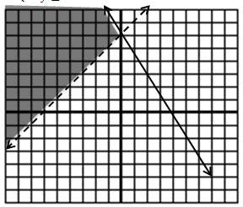(0,0)
   2. (-6,0)
   3. (-8,0)
   4. (0,6)
   5. (2.3)

**MODULE 3:**

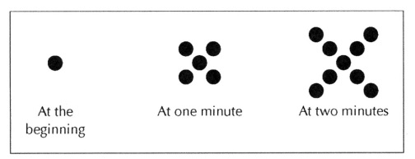 Write an explicit and recursive function.

|  |  |  |  |  |  |  |  |  |  |  |  |
| --- | --- | --- | --- | --- | --- | --- | --- | --- | --- | --- | --- |
| |  |  | | --- | --- | | **Day** | **Number of Dots** | |  |  | |  |  | |  |  | |  |  | |  |

How many dots are there at 100 minutes?

31.

|  |  |  |  |  |
| --- | --- | --- | --- | --- |
| At the beginning | At one minute | At two minutes | At three minutes | At four minutes |

Write an explicit and recursive function.

|  |  |  |  |  |  |  |  |  |  |  |  |
| --- | --- | --- | --- | --- | --- | --- | --- | --- | --- | --- | --- |
| |  |  | | --- | --- | | **Day** | **Number of Dots** | |  |  | |  |  | |  |  | |  |  | |  |

How many dots are there at 25 minutes?

1. Mr. and Mrs. Gloop want their son, Augustus, to do his homework every day. Augustus loves to eat candy, so his parents have decided to motivate him to do his homework by giving him candies for each day that the homework is complete. Mr. Gloop says that on the first day that Augustus turns in his homework, he will give him 10 candies. On the second day he promises to give 20 candies, on the third day he will give 30 candies, and so on.

Recursive Formula: _________________________________ Explicit Formula: _________________________________

Use a formula to find how many candies Augustus will have on day 30 in this plan.

1. Augustus looks in the mirror and decides that he is gaining weight. He is afraid that all that candy will just make it worse, so he tells his parents that it would be ok if they just give him 1 candy on the first day, 2 on the second day, continuing to double the amount each day as he completes his homework. Mr. and Mrs. Gloop likes Augustus’ plan and agrees to it.

Model the amount of candy that Augustus would get each day he reaches his goals with the new plan.

|  |  |  |  |  |  |  |  |  |  |  |  |  |  |  |  |  |  |
| --- | --- | --- | --- | --- | --- | --- | --- | --- | --- | --- | --- | --- | --- | --- | --- | --- | --- |
| |  |  | | --- | --- | | ***# of Days*** | ***# of Candies*** | |  |  | |  |  | |  |  | |  |  | |  |  | |  |  | |  |  | | C:\Users\katie\AppData\Local\Temp\geogebra.png |

Recursive Formula: ________________________________ Explicit Formula: __________________________________

Use a formula to find how many candies Augustus will have on day 30 in this plan.

1. Augustus is generally selfish and somewhat unpopular at school. He decides that he could improve his image by sharing his candy with everyone at school. When he has a pile of 100,000 candies, he generously plans to give away 60% of the candies that are in the pile each day. Although Augustus may be earning more candies for doing his homework, he is only giving away candies from the pile that started with 100,000. (He’s not that generous.)

Model the amount of candy that would be left in the pile each day.

|  |  |  |  |  |  |  |  |  |  |  |  |  |  |  |  |  |  |
| --- | --- | --- | --- | --- | --- | --- | --- | --- | --- | --- | --- | --- | --- | --- | --- | --- | --- |
| |  |  | | --- | --- | | ***# of Days*** | ***# of Candies*** | |  |  | |  |  | |  |  | |  |  | |  |  | |  |  | |  |  | | C:\Users\katie\AppData\Local\Temp\geogebra.png |

Recursive Formula: ________________________________ Explicit Formula: __________________________________



|  |
| --- |
| Fill in the table below for each arithmetic sequence. |
| |  |  |  |  |  |  |  |  | | --- | --- | --- | --- | --- | --- | --- | --- | | x | 1 | 2 | 3 | 4 | 5 | 6 | 7 | | y | -5 |  |  |  |  |  | 13 | |
| |  |  |  |  |  |  |  |  | | --- | --- | --- | --- | --- | --- | --- | --- | | x | 1 | 2 | 3 | 4 | 5 | 6 | 7 | | y | 2 |  |  |  |  |  | 9.38 | |
| Fill in the table below for each geometric sequence. |
| |  |  |  |  |  |  |  |  | | --- | --- | --- | --- | --- | --- | --- | --- | | x | 1 | 2 | 3 | 4 | 5 | 6 | 7 | | y | 2 |  |  |  |  |  | 31,250 | |
| |  |  |  |  |  |  | | --- | --- | --- | --- | --- | --- | | x | 0 | 1 | 2 | 3 | 4 | | y | -6250 |  |  |  | -10 | |

**MODULE 4:**

1. Match the type of interest on the left with the equation used to calculate that interest on the right.

|  |  |
| --- | --- |
| _____ Amount of simple interest owed | a. $A=P{(1+r)}^{t}$ |
| _____ Total amount owed to lender after *t* years of simple interest | b. $i=Prt$ |
| _____ Value after *t* years of depreciation | c. $A=P+P×t × r$ |
| _____ Total amount owed to lender after *t* years of compound interest | d. $A=P{(1-r)}^{t}$ |

1. Write the equation of the line that has a slope of -2 and goes through (-1,- 3) in point slope form.
2. Write the equation of the line that goes through (-5, 11) and (5, -19) in point slope form.
3. Carly is at a car dealership and is trying to decide on which car would be best to buy. Car 1 costs $36, 000 but will depreciate 12% each year. Car 2 costs $30,000, but will depreciate 8% each year. The sneaky salesman tells Carly she should buy Car 1 because even though it costs more now, it will always be worth more than Car 2. Give Carly your very specific advice about which car to buy considering Carly doesn’t know how long she will keep the car. Back up your advice with specific facts.
4. You have saved $1,000, and need to figure out which bank you want to invest your money with. You can choose between the following two banks.

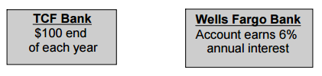

In order to inform your decision, create explicit functions for both banks, and then graph each equation.

|  |  |
| --- | --- |
|  | **TCF Explicit:**  **Wells Fargo Bank Explicit:** |

Which plan is better and when?