**IM3H Module 4 Review**

**Things you should know:**

|  |  |
| --- | --- |
| Scaling factor: Vertical stretch: ,  Vertical shrink:  Reflection over the x-axis    Horizontal translation (left or right  Vertical translation (up or down) | Created by webMathematicaGraph of |
| Created by webMathematicaGraph of |

|  |  |  |  |  |  |
| --- | --- | --- | --- | --- | --- |
| **Half-Angle Formulas** | |  |  | |  |
| **Double Angle Formulas** | |  | | | |
| **Sum and Difference Formulas** |  | | |  | |
| **Even and Odd Trigonometric Functions** | Definition: | | | The cosine and secant functions are even.    The sine, cosecant, tangent, and cotangent functions are odd. | |

Practice Problems

|  |  |  |  |
| --- | --- | --- | --- |
| 1. | | $y=-2\sin\left(4x+π\right)-1$ 2. | |
| 3. | | 4. | |
| Find all solutions in the equation in the interval [0, 2π).  5.  6.  Find all general solutions in the equation  7.  8. | | | |
| 9. Given  and . Find the exact values of cos2θ. | 10. Use the half-angle formulas to find the exact value of sin1050 | | 11. Use the sum formulas to find the exact value of tan2550. |
| 12 What is the period of the function ?  A.  B.  C.  D.  E. None of these | | | |
| 13. What is the amplitude of the function ?  A. 4 B. -6 C. 2 D. 6 E. None of these | | | |
| Verify the identities: | | | |

|  |  |
| --- | --- |
| 14. | 15. |
| 16. | 17. |

18. Find the exact value using a sum or difference formula.

|  |  |  |
| --- | --- | --- |
| a. | b. | c. |

**Evaluate:**

|  |  |  |
| --- | --- | --- |
| 19. | 20. | 21. |

22. Find if and .

23. Find, if .

24. Find , and $angle a and b$ are in the same quadrant.

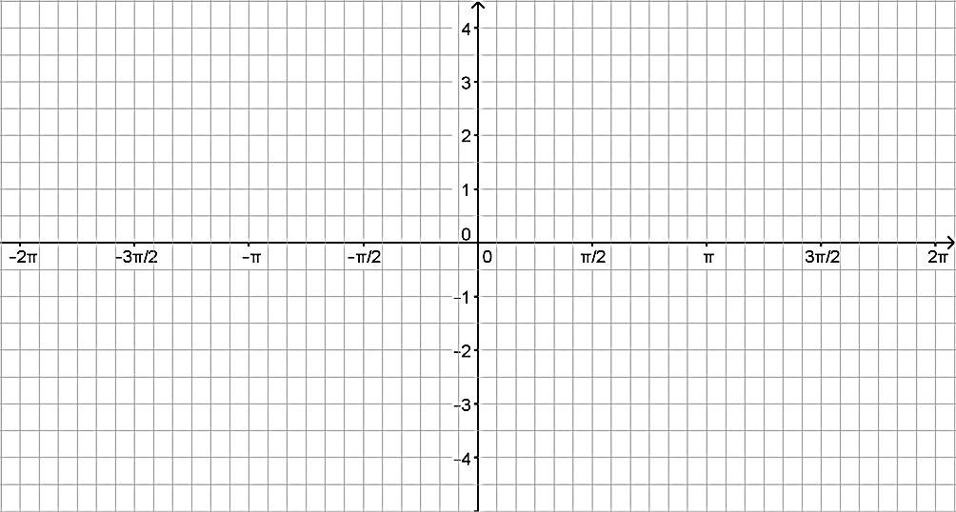25. Graph the function: 

26. Graph the function: 

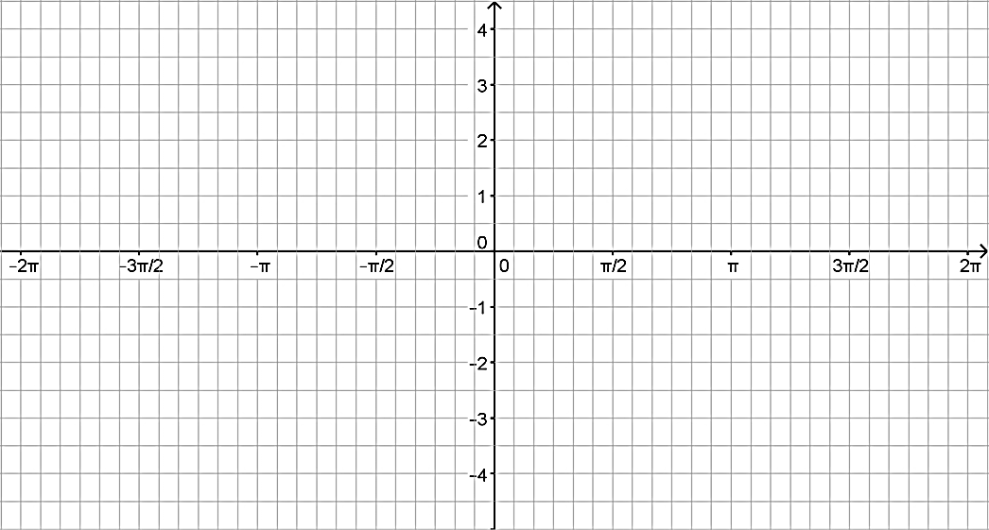

27. Write a sine and a cosine equation for the graph below.   
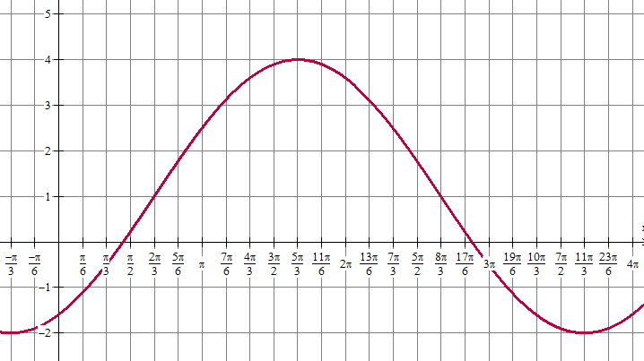

**28. REVIEW FERRIS WHEEL PROBLEMS!!!!**